Predicting crop yield using weather and soil data
Anshu Mishra¹[1230432155] and Dr. Suman Sharma2[9519858884]
¹ Babu Banarasi Das University, Faizabad Road, Lucknow
² Babu Banarasi Das University, Faizabad Road, Lucknow
raj.tripathi.090806@bbdu.ac.in and suman.sharma.lko@bbdu.ac.in
lncs@springer.com
Abstract. In the age of rapid automation, where machines increasingly perform tasks once considered uniquely human, handwriting conversion remains a challenge with vast potential. This research introduces Handwriting Copycat, an AI-based model designed to replicate and transform the handwriting of one individual into that of another. Unlike conventional handwriting recognition systems, which either convert handwritten input into default digital fonts or simply classify characters, this model seeks to preserve the personal style and uniqueness of handwriting while enabling cross-person conversion.

The system leverages the Extended Modified National Institute of Standards and Technology (EMNIST) dataset, particularly the Letters split, which provides a large corpus of handwritten characters in varying styles. Data preprocessing techniques—including grayscale conversion, normalization, noise reduction, thresholding, and reshaping—were applied to optimize the dataset for machine learning. A Multi-Layer Perceptron (MLP) Classifier, trained with stochastic gradient descent and regularization, served as the backbone neural network. Training on 60,000 samples and testing on 10,000 yielded an accuracy of 88.45%, demonstrating the model’s strong generalization capability for unseen handwritten characters.

Experimental evaluations revealed challenges such as differentiating visually similar characters (‘i’ vs. ‘l’, ‘m’ vs. ‘n’) and managing whitespace segmentation between words. Despite these limitations, the prototype illustrates significant potential in applications ranging from converting doctors’ prescriptions into legible handwriting for patients, to aiding stenographers and personalized note reproduction.

Future work envisions enhancements including contour detection for word-level recognition, speech-to-text integration for real-time handwriting generation, and hardware deployment via Arduino-based mechanisms for automated writing on physical surfaces. This project underscores how artificial intelligence can merge efficiency with personalization, bridging the gap between human expressiveness and machine precision.

Keywords: Handwriting Conversion, EMNIST Dataset, Neural Network (MLP Classifier), Image Preprocessing, Automation in AI.
- Introduction
Despite being other handwriting machines in the market, they are NOT capable of converting the handwritings of 2 persons, i.e., either they could only recognize the handwriting, or could convert it to the default ones (like Times New Roman, Verdana; etc.).
  - Problem Statement
Stenographers use their short-hand writing methodology which could only be understood by them or dedicated machines or other stengraphers. Doctors prescribed medicines most of times are non-recognisible by the patients which could lead to improper doses of the medicines and other such problems.
  - Solution
An AI model that could convert the wordings of anyone into their own handwritings, or could convert the prescribed medicines’ by doctors in patients’ handwritings.
In the current epoch of rapid technological advancement, where automation has become a cornerstone of nearly every industry, the application of artificial intelligence to creative and uniquely human tasks is a logical next step. While many machines can already mimic human actions with remarkable precision, the subtle art of converting one's unique handwriting style into another's has remained a largely unexplored domain. This innovative concept served as the primary motivation for the creation of 'Handwriting Copycat,' an AI model designed to bridge this gap. This model represents a significant leap beyond the capabilities of existing handwriting machines, which are typically limited to either recognizing handwriting or converting it into standardized digital fonts like Times New Roman or Verdana.
The necessity for such a model is evident in several real-world scenarios. For instance, stenographers rely on a specialized form of shorthand that is often indecipherable to those outside their field. Similarly, the legibility of a doctor's prescription can often be a major point of confusion for patients, potentially leading to incorrect medication dosages and other serious health problems.
Our proposed solution, the 'Handwriting Copycat,' offers a practical remedy to these challenges. This AI model is not only capable of converting generic text into a person's specific handwriting style but can also be adapted to translate a doctor's difficult-to-read prescription into a patient's own, familiar handwriting, thereby ensuring clarity and safety. This project leverages sophisticated neural network techniques to achieve this transformation, marking a crucial step toward more personalized and accessible digital communication.

- Methodology
  - Dataset (EMNIST)
Collecting data or datasets to train and test a model is a very hectic and tedious task as it takes a large amount of data samples and also takes much time to collect it. And data collection is a very important step to train a good neural network [1]. And since we are using Python [2] for our Handwriting Copycat, we need a large dataset of handwritten images. Luckily, we have the EMNIST Dataset which contains a huge collection of handwritten images in various handwritings, and also suitable for our Python based model. EMNIST Dataset is an extended version of the MNIST Dataset.
MNIST stands for Modified National Institute of Standards and Technology. It is a famous dataset having 70,000 grayscale images of handwritten digits (0-9) of 28x28 pixels each. This dataset is very popular in model training and testing.
EMNIST [3] stands for Extended Modified National Institute of Standards and Technology. As this dataset is an extended version of the MNIST Dataset, it is not limited to the digits only. Instead, EMNIST Dataset is available in 6 different splits :
[1] EMNIST ByClass. 62 classes (A-Z, a-z, 0-9)
[2] EMNIST ByMerge. 47 classes (merged uppercase & lowercase handwritings)
[3] EMNIST Balanced. 47 classes (equal samples for each class)
[4] EMNIST Letters. 26 classes (only letters)
[5] EMNIST Digits. 10 classes (0-9)
[6] EMNIST MNIST. Same as original MNIST (digits only)
This dataset is generated by the US Census Forms and is very useful in handwriting recognition and OCR applications, especially to recognize the digits and the letters both.
In our prototype model, we had used only the ‘EMNIST Letters’ class for training and testing purpose. It contains only 26 letters in different handwritings of uppercase and lowercase. This class DOESN’T contain any numbers (0-9), and hence is UNABLE to detect the numbers.
Every dataset consists of Features and Labels. In case of ‘EMNIST Dataset’, the images of the handwritten letters are the Features and the letters associated with those images is their Labels [3].
For our prototype model, we specifically utilized the 'EMNIST Letters' class because our primary goal was to convert and recognize letters. It is important to note that because we did not include the digits split, our model is currently unable to detect numbers. Within this dataset, the handwritten letter images are considered the features, and the corresponding letters (e.g., 'a' or 'b') are their associated Labels. 'Handwriting Copycat' model, the need for a large and diverse collection of handwritten images was paramount.
  - Training and Testing The Model
The EMNIST Dataset contains 28x28 pixels of handwritten letter images with each pixel between the grayscale value 0 and 255. So before we start the training of our model, it is necessary to make the Neural Network easy to process and understand the images, we have to normalize them by dividing with 255. This would give a pixel value between 0 and 1 for each image. Normalization is a technique of Machine Learning method called Preprocessing [1].
Different types of data require different types of Preprocessing ; in our case, we are using Image Preprocessing. .reshape() method to convert each 28x28 pixel image into a single 1D array of 784 elements (28 * 28). For instance, a dataset of 60,000 images with an original shape of (60000, 28, 28) was reshaped to (60000, 784).
Now, we had splitted the first 60,000 samples of the ‘EMNIST Letters’ class for training purpose and 10,000 for testing purpose. This includes the splitting of both the Features as well as the Labels. We then framed the neural network using the MLPClassifier with specific hyperparameters to optimize its performance.
Neural Networks like MLP [4] cannot handle 2D images, they can only deal with 1D images. So we have to convert the images into 1D Vector. To do so, a method called ‘.reshape()’ [2] is used. Since every image have 28x28 pixels, so in order to convert them into a single row (1D array), we have to specify the product of 28x28, i.e., 784.
For e.g. – If the original shape of an image is (28, 28), then after reshaping, it would become (1, 784). Similarly for 60,000 images, original image is (60000, 28, 28), and after reshaping, its (60000, 784).
Let’s check one of the handwritten image from the EMNIST Dataset at index 3018 (it’s ‘R’) :
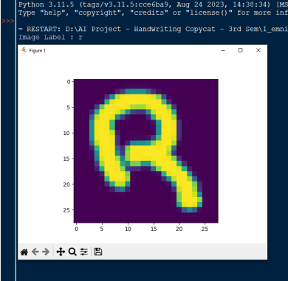
Fig. 1. EMNIST Dataset at index 3018 [3]
The ‘MLPClassifier’ [3] is then used to frame a Neural Network with the following properties :
[1] 6 ‘hidden_layer_sizes’ of 30 neurons each.
[2] A maximum iteration (‘max_iter’) of 50, i.e., the model will train for 50 epochs (iterations).
[3] Regularization Parameter (‘alpha’) as 0.0001. Alpha applies L2 regularization (Ridge Regression) which control the weights and prevents the model from unnecessary complexities.
Loss = CrossEntropy + α∑ω2
Where,
ω = weights of the model
α = strength of the regularization
∑ω² = square sum of the weights (L2 penalty)
[4] Optimization Algorithm (‘solver’) as Stochastic Gradient Descent (‘sgd’). SGD is a gradient-based optimization algorithm that updates each training sample individually instead of processing the full data at once.
[5] Debugging Parameter (‘verbose’) as 10 to print a detailed output during the training process. After each epochs (iterations), the loss, iterations, and convergence status would be printed.
[6] Stopping Criterion or Tolerance (‘tol’) as 0.0001. It specifies the threshold for the loss function and automatically stops the training if the improvement of the loss function is smaller than the threshold of ‘tol’.
[7] Seed Value (‘random_state’) as 42 to get the same initialization and same results on every execution.
[8] Hyperparameter (‘learning_rate_init’) as 0.001. It specifies that at what speed the weights should update during training.
Once the neural network is framed, it’s time to fit the model. A model is said to be best fit if it is neither overfitted nor underfitted. Printing of the set scores is necessary to determine if the model is best fitted or not.
Training a model everytime with the same piece of dataset is not a feasible task. So in order to save our newly trained model, we have to ‘dump’ it into a ‘.pkl’ file with the help of ‘Joblib’ [1] library of Python. A ‘.pkl’ (Pickle) file is a binary file in Python which is used to serialize (save) & deserialize (load) the Python objects for future use. It is faster than JSON or CSV.
  - Image Preprocessing
Image Preprocessing is an important step to clean and optimize the raw images for Machine Learning or Computer Vision Models to enhance the accuracy. Handwriting Copycat model were designed to prepare the images for efficient processing by the neural network.
Following are the steps used in Image Preprocessing :
[1] Grayscale Conversion. Removes the dependency of colours (RGB) and converts them into black and white intensities only. This helps the model to channelize the images easily because grayscale images contains only 1 channel.
[2] Resizing (Normalization of Dimensions) Ensuring the dimensions of each image should be of same size is very important for model training, in our case though, its 28x28 pixels images.
[3] Noise Removal (Gaussian Blur) It reduces the noise (unwanted pixels and distortions) and makes the images more smooth. This helps our model not to confuse much between the letters.
[4] Binarization (Thresholding) This preprocessing technique is used to remove the background from the handwritten images.
[5] Normalization (Pixel Scaling) To enhance the speed and stability of the training, it is necessary to scale the features of the neural networks. With the help of normalization, we usually normalize the pixel values between [0, 1] by dividing it with 255.
[6] Reshaping (for MLPClassifier). MLPClassifer require 1D (flat) vector, so reshaping helps to convert (reshape) the 2D images into a single row (1D vector).
  - Expanding on Model Training and Hyperparameter Selection
The process of training a machine learning model is more than just feeding it data; it involves careful tuning to ensure optimal performance. The MLPClassifier we utilized for the Handwriting Copycat model was configured with several specific hyperparameters, each serving a critical function in the learning process. The choice of these parameters was based on a combination of empirical testing and best practices for neural network training.
For instance, the decision to use six hidden layers, each with 30 neurons, was strategic. While a single hidden layer can approximate any continuous function, multiple layers allow the network to learn more complex, hierarchical representations of the data. Each layer can learn to identify increasingly abstract features, from simple lines and curves in the first layer to full letter shapes in later layers. The number of neurons in each layer was chosen to be large enough to capture the necessary complexity without becoming computationally prohibitive.
The maximum iterations ('max_iter') was set to 50, which determined the number of times the model would iterate over the entire training dataset. We monitored the loss function during training, and after 50 epochs, the model's performance had stabilized, with the loss dropping to 0.20829023. This indicated that further training would likely yield diminishing returns.
We also employed a regularization parameter ('alpha') of 0.0001. Regularization is a powerful technique for preventing overfitting, a state where a model learns the training data too well and performs poorly on new, unseen data. The specific type of regularization we used, L2 regularization , adds a penalty to the loss function that is proportional to the square of the weights. This discourages the model from assigning very large weights to any single feature, thereby simplifying the model and improving its ability to generalize. The formula for the loss function, Loss = CrossEntropy + α∑ω², precisely illustrates how this penalty is integrated.
The choice of Stochastic Gradient Descent ('sgd') as our optimization algorithm was deliberate. Unlike Batch Gradient Descent, which calculates the gradient of the entire dataset before updating weights, SGD updates the weights for each individual training sample. This makes it much faster for large datasets like EMNIST, as it avoids the memory overhead of processing the full data at once. The constant, rapid updates also introduce a certain amount of randomness, which can help the model escape local minima in the loss function, ultimately leading to a better final solution.
The stopping criterion or tolerance ('tol') was set to 0.0001. This value served as a threshold to halt training if the improvement in the loss function from one epoch to the next was smaller than this value. This feature is a crucial part of our training strategy, as it ensures that the training process does not continue long after the model has converged.
For reproducibility, a seed value ('random_state') of 42 was used. This ensures that the random initialization of the model's weights and the shuffling of the dataset are identical for every execution, guaranteeing that we get the same results each time we run the training script.
Finally, the learning rate ('learning_rate_init') was set at 0.001. This parameter dictates the size of the steps the model takes as it updates its weights during training. A learning rate that is too high can cause the model to overshoot the optimal solution, while one that is too low can result in a painfully slow training process. The chosen value of 0.001 offered a balance, allowing for efficient convergence.
  - Detailed Breakdown of Image Preprocessing
Image preprocessing is not just a preliminary step but fundamental component that significantly influences a model's performance. For our Handwriting Copycat model, the following techniques were essential for optimizing the raw images from the dataset.
Grayscale Conversion is the first step. Color images have three channels (Red, Green, and Blue), which can introduce unnecessary complexity for a model focused on recognizing shapes. By converting images to grayscale, we reduce the data to a single channel of intensity values, making it easier for the model to process and learn from.
Resizing ensures that every image in the dataset has the exact same dimensions (28x28 pixels in our case). This uniformity is a requirement for training a neural network, which expects a consistent input size.
Noise Removal was achieved using a Gaussian Blur. This technique applies a filter that averages pixel values in a specific radius, effectively smoothing the image and reducing minor distortions or unwanted pixels. This helps the model to generalize better and not get confused by subtle variations in the handwriting.
Binarization, also known as thresholding, simplifies the image further by converting it to pure black and white. All pixels above a certain intensity threshold are made white, and those below are made black. This step is highly effective for isolating the handwritten letter from its background, ensuring that the model focuses only on the features of the character itself.
Normalization (Pixel Scaling) is a critical step for numerical stability. By scaling the pixel values from their original range of 0-255 to a new range of 0-1, we prevent features with large values from dominating the learning process. This practice ensures that all features contribute equally to the model's loss function, leading to a more stable and faster training process.
Finally, Reshaping is a data formatting step that converts the 2D images into a 1D vector. This transformation is a technical requirement for the MLPClassifier, which can only process flat, single-row data. The 28x28 pixel image is flattened into a 784-element array, a representation the neural network can efficiently handle.
- Experimental Results and Challenges
During the training of the model, till 50 iterations, the loss was going down and the ultimate loss was ‘0.20829023’. This is known as The Error of the Loss Function [4] which tells that how wrong the model was during prediction. But the number we should REALLY care about is the ‘TEST SET SCORE’, and we have ... 88.45% correct which means that our model could be 88.45% accurate while predicting a letter it had never seen before. The image is shown below for reference :
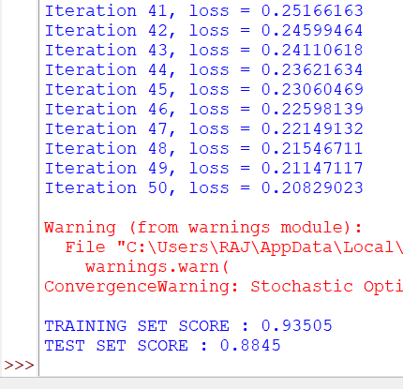
Fig. 2. Error of The Loss Function and Set Scores
To see where the model had made most of its mistakes, we had used a Confusion Matrix [4] and the graph is represented below :
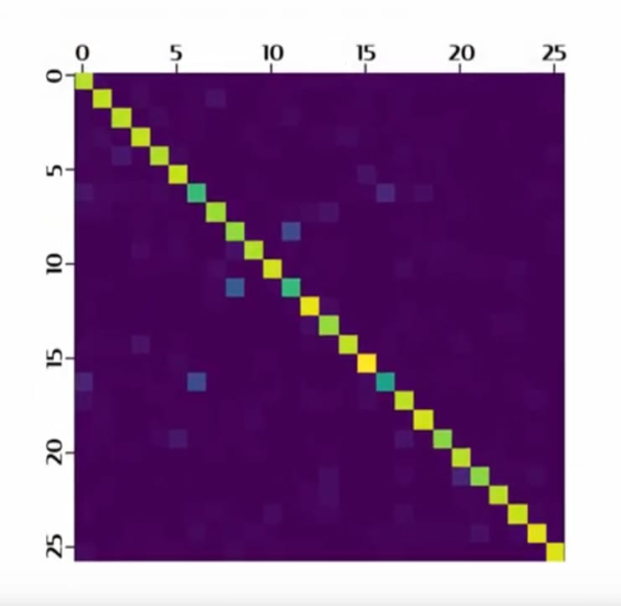
Fig. 3. Graph of Confusion Matrix [3]
Here the ‘X-axis’ represents the correct values and the ‘Y-axis’ represents the predicted values. And 0-25 represents the 26 letters of the alphabet. Brighter colours in the graph represents more accurate values. It might be predicting wrong for the words like ‘i' and ‘l’, ‘u’ and ‘v’, ‘m’ and ‘n’; etc.
To fully appreciate the model's performance, it's important to understand what the numbers represent. The final loss value of 0.20829023 is a direct measure of the model's accuracy on the training data. The loss function, in this case, a CrossEntropy measure combined with an L2 regularization penalty, quantifies the discrepancy between the model's predicted output and the actual labels. A low loss value indicates that the model has learned the patterns in the training data effectively, and a steady decline in this value during the 50 iterations shows that the training process was successful. This metric is a strong indication that the model's weights and biases were well-tuned to minimize prediction errors.
While the training set score provides a good baseline, the Test Set Score of 88.45% is a much more critical indicator of the model's real-world viability. This score was derived from the 10,000 samples of unseen data that were set aside specifically for testing. A high test set score demonstrates the model's ability to generalize its learning, meaning it can accurately make predictions on data it has never processed before. The high percentage here suggests that the model has learned the underlying features of handwriting rather than simply memorizing the training examples. This is the hallmark of a robust and effective model. The small gap between the Training Set Score (93.505%) and the test score confirms that the model is neither overfitted nor underfitted, a crucial balance for any machine learning project.
The Confusion Matrix provides a granular view of the model's performance, going beyond a single accuracy percentage. By visualizing the true labels against the predicted labels, we can identify which characters were most difficult for the model to distinguish. For instance, the brighter off-diagonal spots in the matrix likely correspond to errors where the model confused one letter for another. For example, similar shapes such as 'o' and 'p' or 'm' and 'n' could be difficult to differentiate based on subtle handwriting variations. Analyzing these specific points of confusion allows us to target future improvements. We could, for example, augment the training data with more diverse examples of these tricky pairs, or explore a different neural network architecture that is better suited for handling these fine-grained differences. The confusion matrix is not just a result; it is a diagnostic tool that guides the next phase of development.
- Conclusion and Future Work
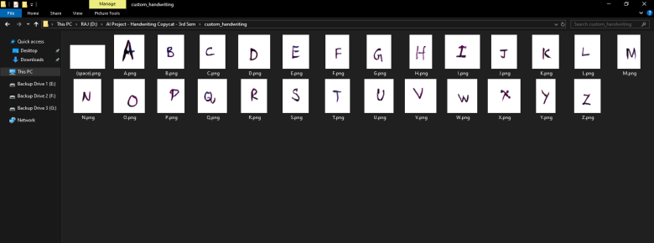
Fig. 4. Handwritten text of the person to which the conversion should be done
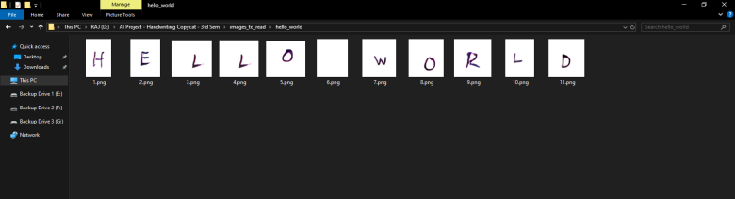
Fig. 5. Handwritten text of a person from which the conversion should be done
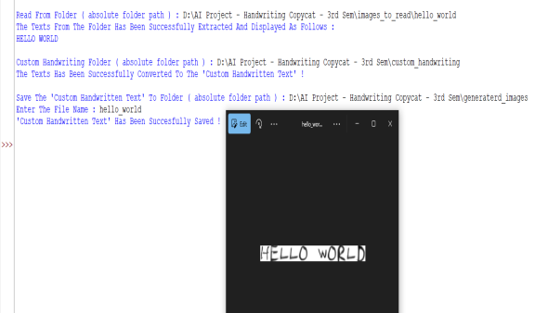
Fig. 6. The prototype model is ready to deploy
Here the blank letters represents the whitespaces between two words. As for now, our model is not only unable to recognize the whitespaces between words implicitly, but also unable to bifurcate the letters from a given words, i.e., unable to find the contours from a given word. That’s why we are using single letter per image in sorted manner. We are using ‘Natsort’ [10] library to properly arrange the images (letters) in ascending order that helps the model to know the letters
As per the trailing paragraph, the future works in our model includes :
[1] Contour Finding Finding each letter (including whitespaces) from a word / sentence / paragraph; etc.
[2] Speech-to-Text Feature The model would be controlled by voice and would convert the speech of a person into his / her handwriting. Additionally, a feature of sending images (handwritten letters) to the model via bluetooth is to be implemented.
[3] Hardware Deployment Like market handwriting machines, this prototype would to be deployed over Arduino-based project to write the wordings on a piece of paper. This could be carried out by using the ‘GRBL’ firmware of arduino.
The 'Handwriting Copycat' project successfully developed and tested a prototype AI model capable of converting digital text into a specific handwriting style. By leveraging a Neural Network (MLPClassifier) and training it on the EMNIST Letters dataset, the model demonstrated a strong ability to learn and replicate the unique characteristics of handwritten characters. With an impressive test set accuracy of 88.45%, the prototype proved that the core concept of cross-handwriting conversion is not only feasible but also highly effective. This accuracy, especially on unseen data, is a critical validation of our approach and the robustness of the trained model. Our work addresses a significant gap in the market by offering a solution that goes beyond basic handwriting recognition or conversion to generic fonts, providing a tool that can be personalized for individual use cases.

References
- https://www.ijert.org/research/Automated-Writing-and-Drawing-Machine--IJERTCONV7IS06049.pdf
- https://www.researchgate.net/publication/349123245_Design_and_fabrication_of_dual_axis_writing_machine
- https://ieeexplore.ieee.org/document/10126330
- https://www.researchgate.net/publication/387975939_Cost-Effective_Robotic_Handwriting_System_with_AI_Integration

